NEWS!

SPIDER 300 TANLAW TELESCOPE TO BE INSTALLED IN SRI LANKA TO PROBE THE MYSTERIOUS KORDYLESKWI CLOUDS

Lord Simon Tanlaw, through his long-standing links with Sri Lankan-born British astronomer Professor Chandra Wickramasinghe, has arranged for a SPIDER-300 Radio Telescope (image below) with up to the minute technology to be installed at the University of Colombo, Sri Lanka. In addition to this instrument an optical telescope (reflecting telescope), with the same specifications as the telescope at Kitt Peak Observatory is also to be installed thanks to the generosity of Lord Tanlaw.

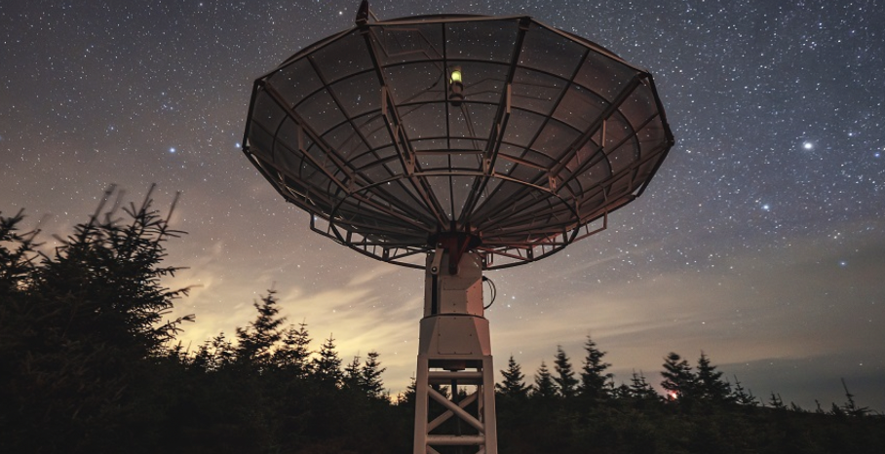

One of the first projects that Professor Wickramasinghe hopes to initiate with the new radio telescope is to probe what are called the Kordyleskwi clouds. These are gigantic clouds of dust that trail in front of and behind the Moon. The existence of the clouds has been known for a few decades, and one mysterious aspect of the clouds is that they seem to be emitting radio signals that have been picked up by observers on the Earth https://dx.doi.org/10.22606/adap.2019.44001. There have even been claims that these may be intelligent signals directed at our planet. For this reason, if no other, studying the clouds carefully would be a crucially important project. Chandra Wickramasinghe and Prof Robert Temple together with scientists at Colombo University are hoping to use the new telescope to probe these mysterious clouds.

The installation and inauguration of the telescopes in Sri Lanka are to take place in the first week of December 2026.

REFERENCES
Hoyle, F., 1957, The Black Cloud (London: Heinemann)
Hoyle, F and Wickramasinghe, N.C., 1970. Radio waves from grains in HII regions, Nature, 227, 473
Temple, R., 2022. A New Science of Heaven, Hodder & Stoughton, London, 2022.
Temple, R., 2025a. Journal of Cosmology, Volume 16, November 10, 2025, pp. 35000-35094.
Temple, R. and Wickramasinghe, C. 2019. Kordylewski Dust Clouds: Could They be Cosmic Superbrains? Advances in Astrophysics, Vol. 4, No. 4, November 2019
https://dx.doi.org/10.22606/adap.2019.44001

